PATENT QUOTATION FOR INDIAN PATENT FILING
Dated: 30/12/2025
Addressed to: Dr. Umamaheshwar Reddy
Quotation Prepared by: Adv. Sharan Kumar
Contact Details: +91-8971411232
Email: info@lextria.in / aminsharan.astraea@gmail.com
Sl. No | Particulars | Cost (Govt Fee + Prof Fee + Misc.)
1. | Patent searching with oral opinion, Provisional specification drafting, filing (Inclusive of Govt fees) | 1,600+20,000+900 = 22,500/-
2. | Patent searching with oral opinion, Complete specification drafting, filing and request for early publication with expedited examination (Inclusive of Govt fees) | 8,100+40,000+900 = 42,000/-
3. | Response to Examination | 0+35,000+0 = 35,000/- (per examination)
4. | Attending hearing | 0+10,000+0=10,000/- (per hearing)
5. | Filing written submission for the hearing | 0+40,000+0=40,000/- (per submission)

Notes:
- An 18% GST will be applied to the professional fees.
- In case a similar quotation is required again for any other service, kindly reach out to us, and we will be happy to assist you.
- Any additional reimbursements, if applicable, will be informed to you priorly for your approval before proceeding.

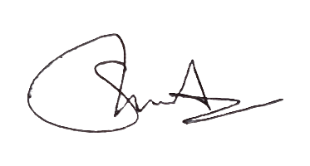
Should you have any questions or require further clarification, please feel free to contact us at the provided email or phone number. Thank you for considering our services. We look forward to assisting you with your intellectual property needs.

Best Regards,
Adv. Sharan Kumar, IP and Corporate affairs
Lextria Research

